Practical No : 01
Aim :- Print “hello world” in PHP.

<html>

<body>
<?php
echo "Hello World !";
?>
</body>
</html>
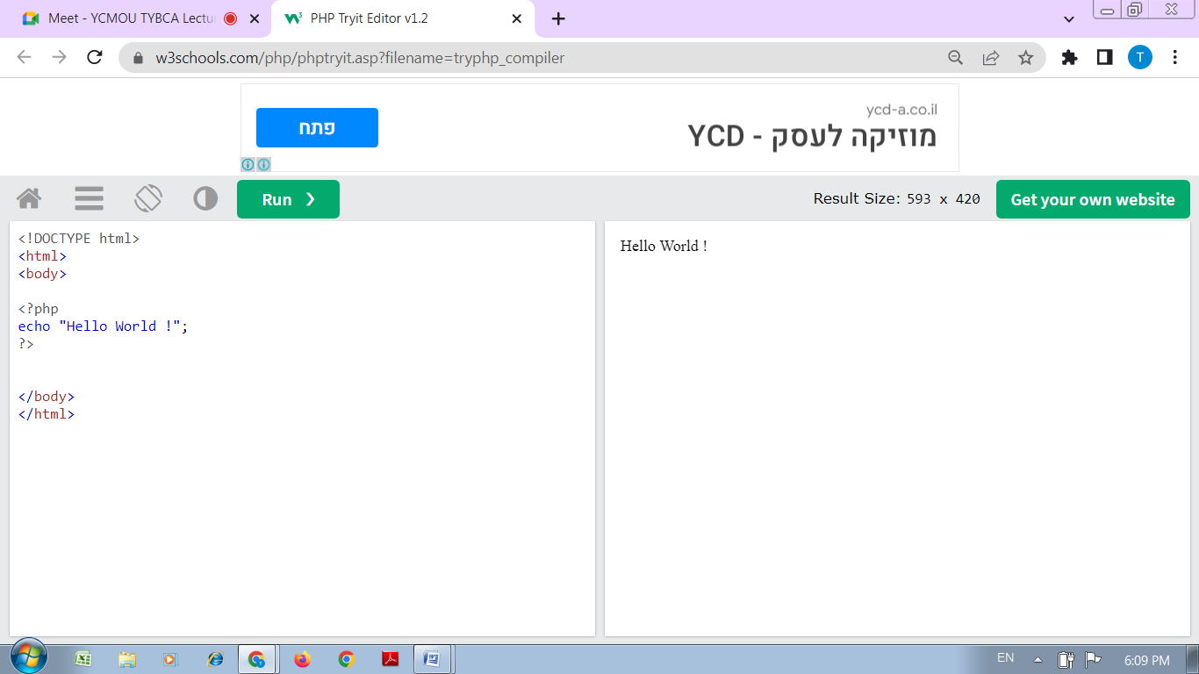

Practical No : 02
Aim :- Write a PHP program to print sum of digits.

<html>
<body>
<?php
$num = 14597;
$sum=0; $rem=0;
for ($i =0; $i<=strlen($num);$i++)
{
$rem=$num%10;
$sum = $sum + $rem;
$num=$num/10;
}
echo "Sum of digits 14597 is $sum";
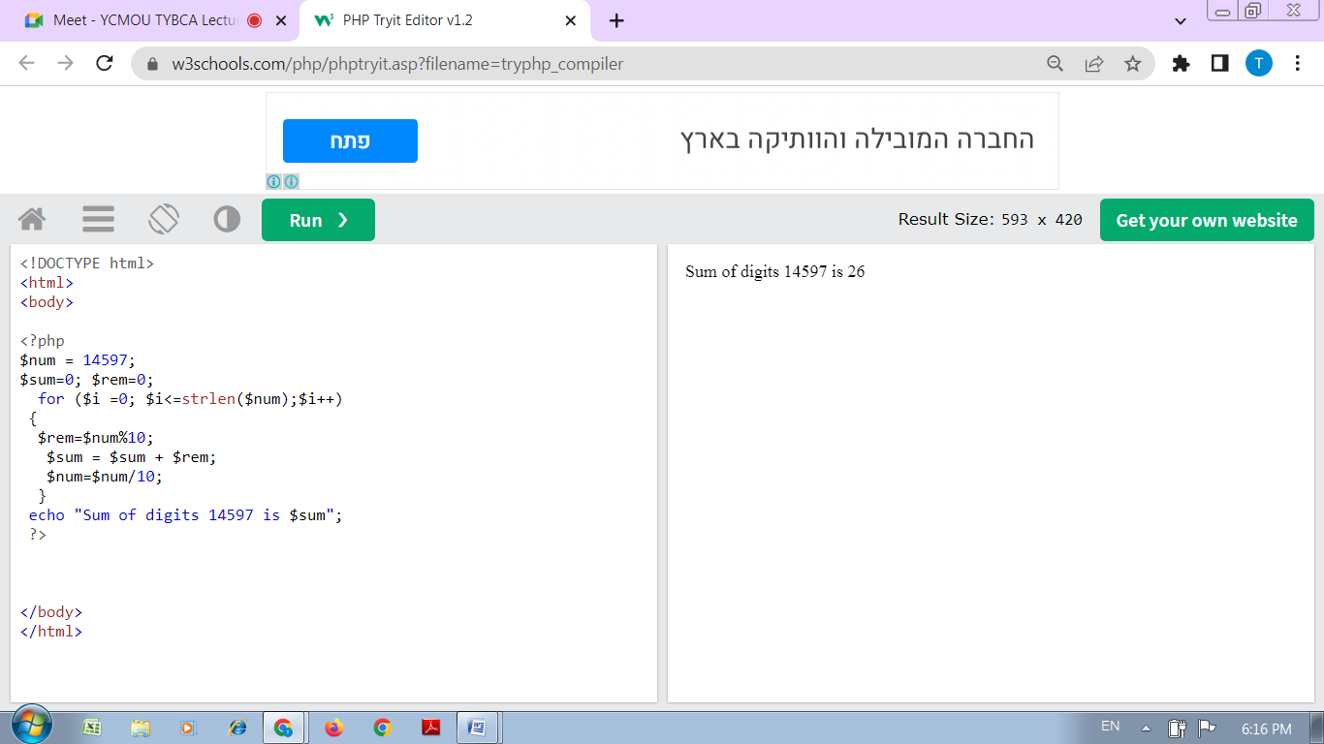
?>
</body>
</html>

Practical No : 03
Aim :- Write a PHP program to check prime number.

<html>
<body>
<?php
function check_prime($num)
{
if ($num == 1)
return 0;
for ($i = 2; $i <= $num/2; $i++)
{
if ($num % $i == 0)
return 0; }
return 1; }
$num = 47;
$flag_val = check_prime($num);
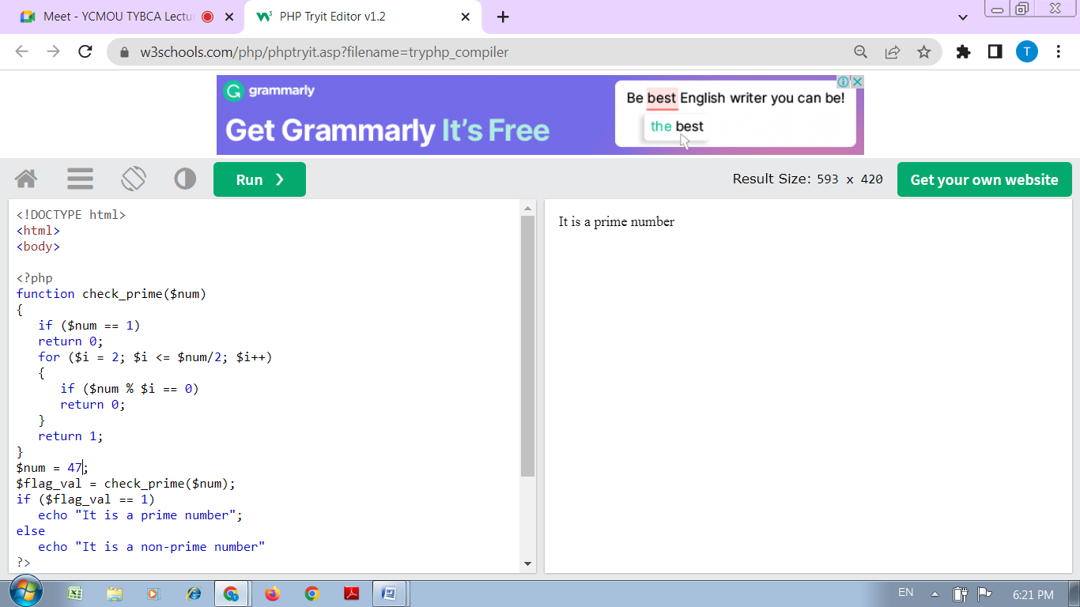
if ($flag_val == 1)
echo "It is a prime number";
else
echo "It is a non-prime number"
?>
</body>
</html>
Practical No : 04
Aim :- Write a PHP program to print factorial of a number.

<html>
<body>
<?php
$num = 4;
$factorial = 1;
for ($x=$num; $x>=1; $x--)
{
$factorial = $factorial * $x;
}
echo "Factorial of $num is $factorial";
?>
</body>
</html>
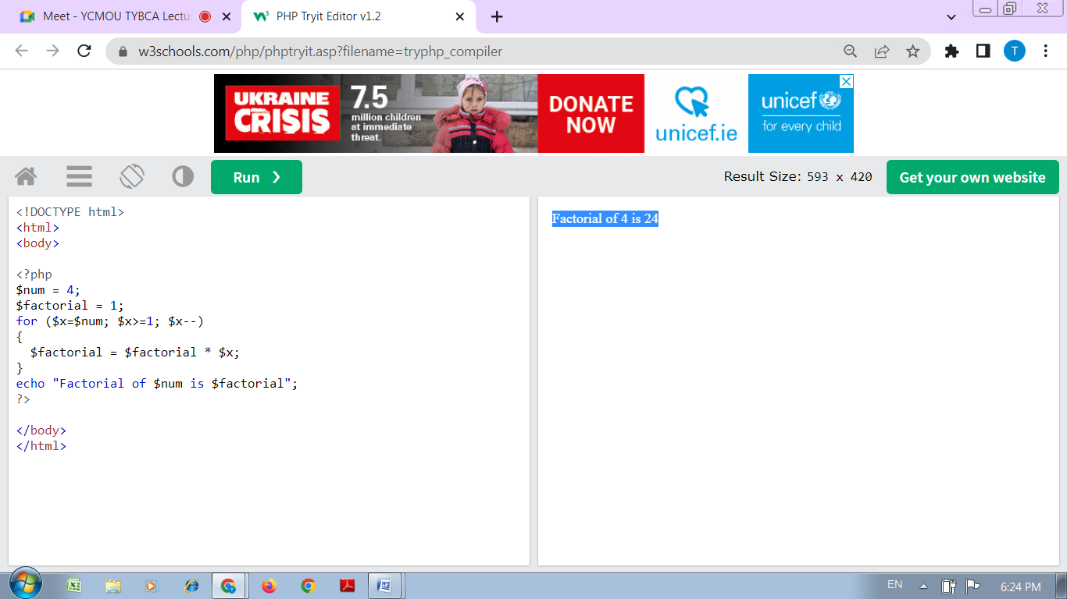
Practical No : 05
Aim :- Write a PHP program to sort elements in an array in ascending order.
<html>
<body>
<?php
$cars = array("Volvo", "BMW", "Toyota");
sort($cars);
$clength = count($cars);
for($x = 0; $x < $clength; $x++) {
echo $cars[$x];
echo "<br>";
}
?>
</body>
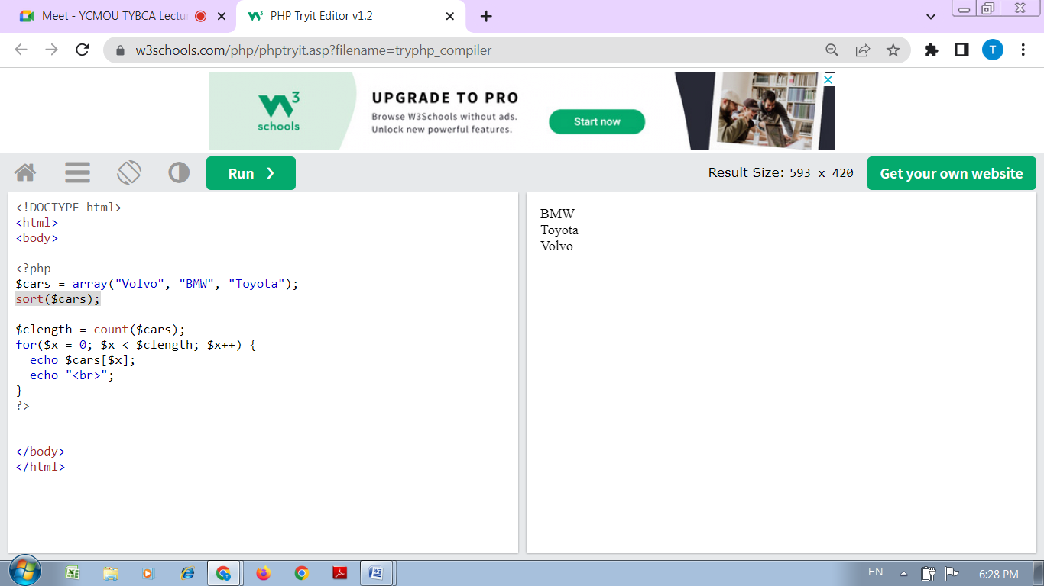
</html>

Practical No : 06
Aim :- Create a PHP program to calculate its addition, subtraction, multiplication, modulation, average and division on the same page.

<html>
<body>
<?php
$x=100;
$y=60;
echo "The sum of x and y is : ". ($x+$y) ."<br />";
echo "The difference between x and y is : ". ($x-$y) ."<br />";
echo "Multiplication of x and y : ". ($x*$y) ."<br />";
echo "Division of x and y : ". ($x/$y) ."<br />";
echo "Modulus of x and y : " . ($x%$y) ."<br />";
?>
</body>
</html>
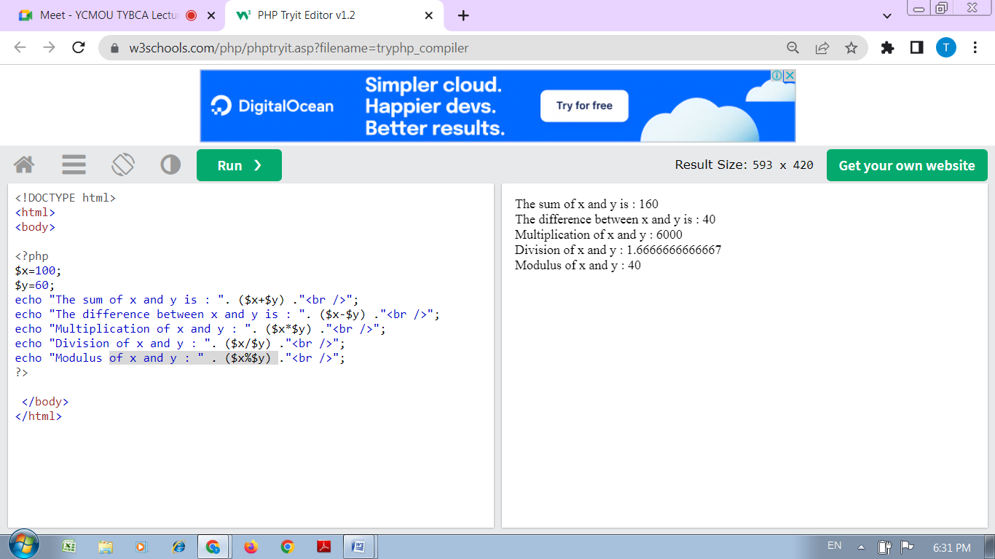
Practical No : 07
Aim :-
Write a PHP Program to create a simple Registration form.

<html>
<head>
<title>Registration Form</title>
<meta http-equiv="Content-Type" content="text/html; charset=UTF-8">
</head>
<body>

<h2>Registration Form</h2>

<form action="registration_form.php" method="POST"> First name:

<input type="text" name="firstname"> <br> Last name:

<input type="text" name="lastname">

<input type="hidden" name="form_submitted" value="1" />

<input type="submit" value="Submit">

</form>
</body>
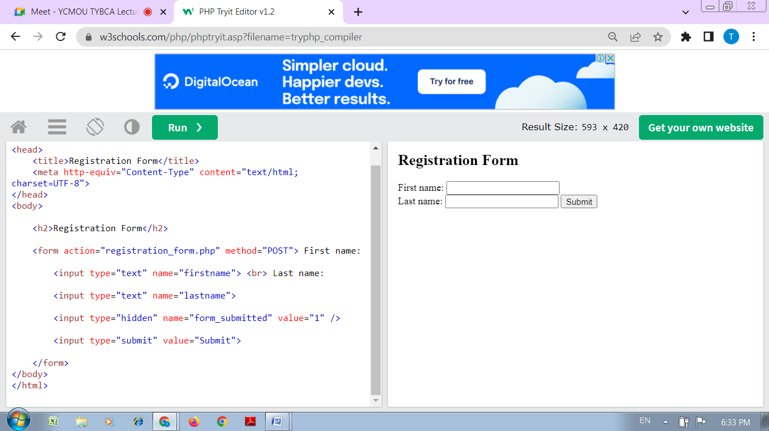
</html>

Practical No : 08
Aim :- Write a program to create a file in write mode.

<html>
<body>
<?php
$fp = fopen('data.txt', 'w');//opens file in write-only mode
fwrite($fp, 'welcome ');
fwrite($fp, 'to php file write');
fclose($fp);
echo "File written successfully";
?>
</body>
</html>
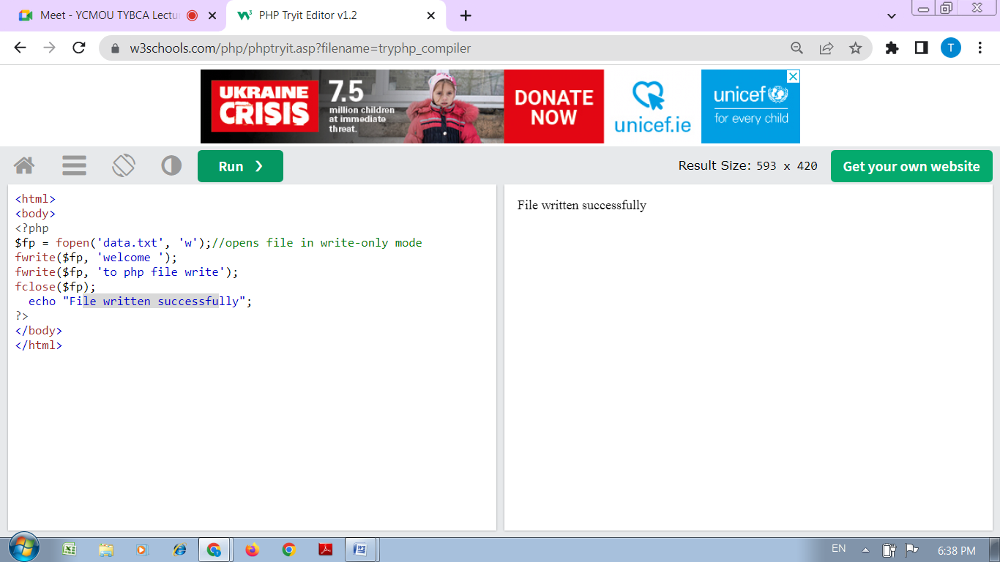

Practical No : 09
Aim :- Write a program to read and display the contents of file.
<html>
<head>
<title>Reading a file using PHP</title>
</head>
<body>
<?php
$filename = "tmp.txt";
$file = fopen( $filename, "r" );
if( $file == false ) {
echo ( "Error in opening file" );
exit(); }
$filesize = filesize( $filename );
$filetext = fread( $file, $filesize );
fclose( $file );
echo ( "File size : $filesize bytes" );
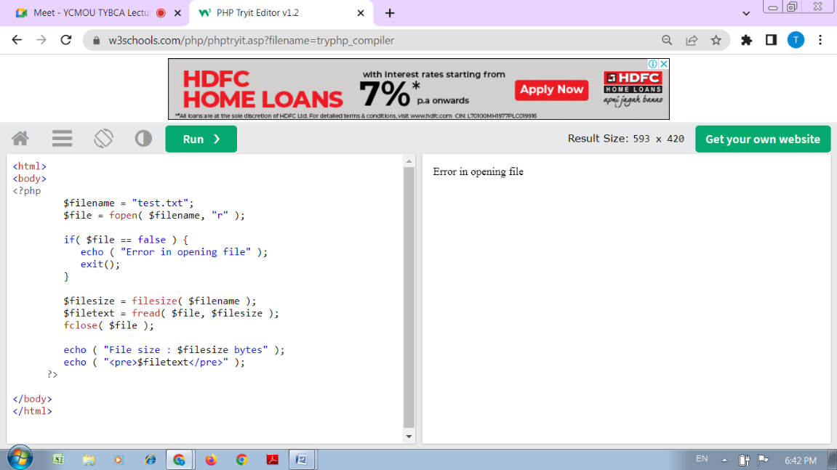
echo ( "<pre>$filetext</pre>" );
?>
</body>
</html>

Practical No : 10
Aim :- Write a PHP script to display string, values, within a table.

<html>
<body>
<?php
$a=1000;
$b=1200;
$c=1400;
echo "<table border=1 cellspacing=0 cellpading=0>
<tr> <td><font color=blue>Salary of Mr. A is</td> <td>$a$</font></td></tr>
<tr> <td><font color=blue>Salary of Mr. B is</td> <td>$b$</font></td></tr>
<tr> <td><font color=blue>Salary of Mr. C is</td> <td>$c$</font></td></tr>
</table>";
?>
</body>
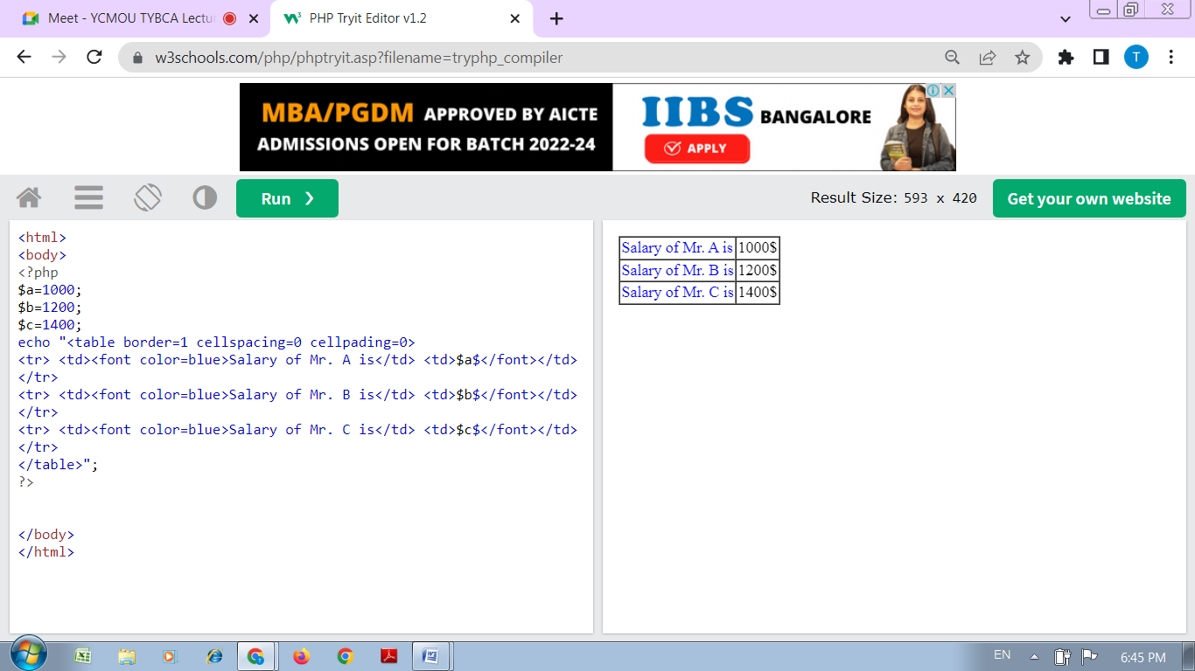
</html>

Practical No : 11
Aim :- Write a PHP Script to get Last occurred error.

<html>
<body>

<?php
echo $x;
print_r(error_get_last());
?>
</body>
</html>

